**Savitribai Phule Pune University**



*A PRELIMINARY PROJECT REPORT*

*ON*

**“Blood Bank Management System”**

Submitted by

Under the guidance of

**Prof. Nikita Chaudhari**



**T.Y.B.Sc. (CS) - VI Semester**

**Department of Computer Science**

**Nowrosjee Wadia College, Pune-411001**

[2022-23]

***Certificate***

This is to certify that the Project Entitled

**“Blood Bank Management System”**

*SUBMITTED BY*

**Sayali Barhate - 07**

**Kirti Bartakke – 08**

**Shruti Choudhari – 22**

**Shirley Dhawadkar – 26**

*is a bonafide work carried out by Students under the supervision of Prof.* ***Dr. Reena Bharathi and Prof. Nikita Chaudhari*** *and it is submitted towards the partial fulfilment of the requirement of Bachelor of Science (Computer Science).*

**Prof. Nikita Chaudhari** **Prof. N.D. Abhyankar**

Guide HOD, Department of Computer Science

Place: Nowrosjee Wadia College, Pune

Date:

## 

## Abstract

Blood transfusion stands to be a prominent public health and safety concern. The ready availability of required blood types in a specific window of time can be hard to manage even today.

These little errors in the medical sector, however, are not easily permissible as even small ones can be fatal. lack of availability of these blood products and provision of unsafe blood products still impacts morbidity and mortality.

Using online blood bank management system, blood transfusion safety is expected to be enhanced or improved.

Risks on improper blood donors’ documentation, and misplaced records can be minimized or totally avoided. Also, processes involving blood bag collection, storage, and inventory will be systematized and organized, hence, improving the healthcare management.

### **ACKNOWLEDGEMENT**

It gives us a great pleasure in presenting this report on project “**Blood Bank Management System “.**

We would like to express our deep sense of gratitude to our Class Advisor **Prof. Dr. Reena Bharathi** for an exemplary guidance, monitoring and constant encouragement throughout this project and deep regards to our project guide **Prof. Nikita Chaudhari** for encouraging us to complete this project.

We have furthermore to thank Computer Science Department HOD **Prof. N.D. Abhyankar** for encouraging us to go ahead and for his continuous guidance.

We thank with all our heart and express our honor and deep gratitude to all the staff members of Computer Science Department for helping us in every way possible for them.

We would like to thank all those, who have directly or indirectly helped us in the completion of the work during this project work.

Sayali Barhate

Kirti Bartakke

Shruti Choudhari

Shirley Dhawadkar

**Contents**

Title 1

Abstract 3

Acknowledgement 4

**Chapter TITLE PAGE NO.**

1. **INTRODUCTION**
   1. **MOTIVATION…………………………………………………………………….9**
   2. **PROBLEM STATEMENT………………………………………………………..10**
   3. **LITERATURE SURVEY………………………………………………………….11**
   4. **PROJECT SCOPE………………………………………………………………...12**
   5. **LIMITATIONS………………………………………………………………....….13**
2. **SYSTEM ANALYSIS**
   1. **EXISTING SYSTEMS**
      1. **SCOPE AND LIMITATIONS………………………..14**
   2. **PROJECT PERSPECTIVES**
      1. USER PERSPECTIVE……………………………………………….15
      2. ADMIN PERSPECTIVE……………………………………………...15
   3. **PROJECT FEATURES…………………………………………………………….15**
   4. **STAKEHOLDERS………………………………………………………………… 16**
   5. **REQUIREMENT ANALYSIS**

|  |  |  |  |  |
| --- | --- | --- | --- | --- |
| **`** | | **2.5.1** | **FUNCTIONAL REQUIREMENTS……………………………….** | **16** |
|  | | **2.5.2** | **PERFORMANCE REQUIREMENTS…………………………….** | **17** |
|  | | **2.5.3** | **SECURITY REQUIREMENTS……………………………………** | **17** |
| **3** | **SYSTEM DESIGN** | | |  |
|  | **3.1 DESIGN CONSTRAINTS………………………………………………………..**  **3.2 SYSTEM MODEL**  **3.2.1 CLASS DIAGRAM………………………………………………….** | | | **18**  **19** |
|  | **3.2.2 SEQUENCE DIAGRAM…………………………………………...** | | | **20** |
|  | **3.2.3 ACTIVITY DIAGRAM…………………………………………….** | | | **21** |
| **3.2.4** | | | **DEPLOYMENT DIAGRAM**……………………………………… **21** | |

* + 1. **OBJECT DIAGRAM**………………………………………………. **22**
    2. **COMPONENT DIAGRAM**…………………………………………. **23**
    3. **USE CASE DIAGRAM**…………………………………………………**24**
    4. **ARTIFACT DIAGRAM**……………………………………………**24**
    5. **STATE CHART DIAGRAM** ………………………………………**25**

**3.3 USER INTERFACES**……………………………………………………………… **26**

**4 IMPLEMENTATION DETAILS**

**4.1 SOFTWARE REQUIREMENTS**………………………………………………… **28**

**4.2 HARDWARE REQUIREMENTS**………………………………………………  **29**

**5 OUTPUTS AND REPORT TESTING**

**5.1 TEST PLAN**………………………………………………………………………  **30**

**5.2 BLACK BOX TESTING**………………………………………………………… **32**

**5.3 WHITE BOX TESTING**………………………………………………………… **34**

**5.4 FORM DESIGNS…………………………………………………………………35**

**6 CONCLUSIONS**…………………………………………………………………………  **44**

**7 FUTURE SCOPE** …………………………………………………………… **45**

**8 REFERENCES AND BIBLIOGRAPHY** …………………………………..**46**

**9 FORMS AND ASSIGNMENTS**

**THE**

**BLOOD BANK**

**MANAGEMENT**

**SYSTEM**



**Team members**:

07 Sayali Barhate

08 Kirti Bartakke

22 Shruti Choudhari

26 Shirley Dhawadkar

Chapter 1

**Introduction to proposed System**

* 1. **Motivation:**

Blood transfusion stands to be a prominent public health and safety concern. The ready availability of required blood types in a specific window of time can be hard to manage even today. These little errors in the medical sector, however, are not easily permissible as even small ones can be fatal. lack of availability of these blood products and provision of unsafe blood products still impacts morbidity and mortality.

Using online blood bank management system, blood transfusion safety is expected to be enhanced or improved. Risks on improper blood donors’ documentation, and misplaced records can be minimized or totally avoided. Also, processes involving blood bag collection, storage, and inventory will be systematized and organized, hence, improving the healthcare management.

Furthermore, managing the blood bags in the blood bank will be much easier because each blood bag has an information about the donor, donation activity details, and the expiration date. Also, doctor can use this system to serve blood bags to their patient and monitor the details of the donor.

**The main motivations to develop such a system are:**

• To have a system that is organized in managing blood donor records and blood donation activities.

• Support fast searching to find match blood bags for the right person.

• To provide synchronized and centralized donor and blood stock database.

• To provide immediate storage and retrieval of data and information.

* 1. **Problem statement:**
* The problem definition of the system is to override issues from existing online blood bank management system.
* To launch interactive medium for all kind of users for donating and receiving blood easily.

**Context of problem:**

Majority of blood bank management systems follow traditional data entry methods, that cause financial loss. Manual data entries require labor funding, when it is technically possible to cut labor cost by use of latest technology. The integrity and precision of the data, entered the database cannot be guaranteed by manual entries.

**Issue:**

Conventional working practices might result in inaccurate information, excessive time, security risks, and inadequate funds. Data must be updated often and continuously in the internet age. The upgraded information offers significant, comprehensive, and factual data and makes it easier to believe the web source.

**Relevance:**

Most of the mentioned challenges will be resolved by the envisioned blood bank management system. The data will be precise and thorough, with no random errors, due to the reduced manual labor. We will manage the user and site data with great care and solid security, by limiting the database access only to the admin. To give real-time information, data will occasionally be updated and synchronized. Strong security will be provided for the database to guard it against any data breaches and loss of any user's personal information.

* 1. **Purpose/objective and Goals:**

1. **Purpose:**

* The web-based blood donation system primarily used to assist patients who require blood transfusions.
* This document primarily focuses on giving the blood bank authorities adequate design information.
* Also, it will briefly meet the functional, design, and performance criteria of the system.

1. **Objective:**

* A blood bank management software can be of great assistance in raising awareness and resolving all the possible issues because it quickly offers necessary information and facilitates quicker decision-making.
* Also, this simplifies the process to encourage people to donate blood.
* Objective of this project is to maintain the Blood Bank System.
* They must maintain donor details, Blood component stock details, Screening details, Component preparation details, Blood request details, Compatibility details, Blood issue details, Monthly statistics.

1. **Goals:**

* To make blood easily accessible for receiver.
* Easy to use interactive web-application for every kind of user.
* Smart record handling and updating.
  1. **Literature survey:**

Various Inspiring studies have been done in the field of blood banks before which makes it ever more exciting to research on it and come up with our own take on Blood bank management.

**Some of the previously done works are-**

|  |  |  |  |  |
| --- | --- | --- | --- | --- |
| Sr.No | Paper Title | Author | Publication/  Conference | Description |
| 1 | A Study on Blood Bank  Management | Teena, C.A, Sankar, K. and Kannan | IDOSI publications  (2014)  Middle-East Journal of Scientific Research 19 (8) | This paper defined Blood Bank Management System as an information management system that contributes the management of donor records and blood bank. |
| 2 | Automated online blood bank database | Muhammad Arif, S.Sreevas, K.Nafseer,  R.Rahul | Annual IEEE Indian Conference  (INDICON-2012) | This paper gives insights of how one can use direct call routing technique using asterisk. There will be a central server managing all other blood bank servers. |
| 3 | A lifesaving application | Ramakant Gawande,  Narendra Gupta,  Nikhil Thengadi | International Research Journal of Modernization in Engineering Technology and Science  (2021) | This paper consists of ways in which the donors can be linked to a system. The system will maintain database that will hold donor info according to locality. |

* 1. **Project Scope:**

The Blood Bank Management system's primary goal is to streamline the blood donation and allowance procedures at the blood bank. By this project, we hope to illustrate how to use MySQL operations for creating, reading, updating, and deleting data.

The details of the organization/user are added first in this project. Once registration is complete, the organization/user can add the blood donor's information, including blood type, quantity, and age. Now, when a patient requires blood, application can quickly identify the most suitable blood group and give it to the recipient.

* + 1. **Limitations:**
* In the previous systems searching was in dire straits donors within most cities but not for each city.
* Many a times the contact person’s details were received but were not sufficient again and again.
* Due to lack of connectivity these services cannot reach the agricultural, village areas. Data connection is not economically viable to poor citizens.
* Therefore, the applications were also not available in offline systems. Also, sometimes it absolutely was difficult to get in touch with the hospitals in emergency situations.
* There was no centralized database of volunteer donors. So, it became tedious for one to travel searching for blood just in case of emergency.
* The only option in such situations is to manually looked for donors, match and then make phone calls to every donor.

Chapter 2

**System Analysis**

* 1. **Existing System**
* The Existing System are the online blood bank management websites or the manual blood banks.
* There are two types of process in the existing system: the blood donation process by donors, and the blood request process by hospitals.
* In both processes, an administrator is incharge of managing the blood inventory in the blood bank.
  1. **Scope and limitations of existing systems**

SCOPE:

* Traditional blood banks organize camps and store all the data records in offline mode.
* All the paper work is done manually.
* Collect blood samples from available donors.
* Send blood to hospital or patients as required.
* Spread awareness for blood donation.

LIMITATIONS:

* Lack of security of data.
* Time consuming.
* Consumes large volume of paper work.
* Needs manual operation and is not up to date.
* System is less efficient as data can be lost or replaced leading to further problems.
  1. **Project perspective, features:**

PERSPECTIVE:

* The traditional and the dominant perspective is the task perspective: It focuses on the work or the task itself.
* It is a perspective of those executing the project's activities and uses a rational approach.
* USER perspective:
* The perspective of this project is to make it user friendly, efficient, and easy to use.
* There should be flexibility and clarity of information.
* Donors, receivers, camp organizers should get proper information and updates.
* New users should be comfortable with the interface hence making the UI more efficient and decent.
* ADMIN perspective:
* Admin should be able to fetch all the data records in clear and organized manner.
* He should be able to manage and update all the data.
* The interface for managing the data should be feasible and efficient with data security and rate of data storage.

FEATURES:

* User accounts to control the access and maintain security.
* Database to store well defined and organized records.
* Easy and fast retrieval of information providing better accessibility.
* Minimized manual data entry and calculation resulting in accuracy of work.
* Easy to understand by user and operator.
* Donor and patient can interact with each other with the help of system to get emergency transactions.
* Allows good documentation about the donor and their blood donation activities.
* List the availability of blood bags at any given time.
  1. **Stakeholders:**
* A stakeholder can be any person, group or organization that has a concern or interest in a business or project.
* Stakeholders may include users, providers, governance, suppliers, internal staff, members, customers, and it also may include purchasers, clients, owners, and non-governmental organizations.

**Types of stakeholders** –>

* + - Organizers – Planning, meeting all stakeholders; Preparation of pamphlets, banners, posters; Health talks; Preparation dos and don’ts of blood donation; Co-ordination of all activities.
    - School teachers – Holding rally; conducting health talks along with doctors; spreading awareness.
    - Youth Organization – Community mobilization; spreading awareness; arranging venue.
    - Media – Advertisement about blood donation camp; Distribution of pamphlets through newspapers; Media coverage during blood donation camp.
    - Support staff – Screening short film about voluntary blood donation in the hospitals; Line listing, Housekeeping, etc.
    - Field staff – Awareness generation; Taking out rally; Distribution of pamphlets; Posters at strategic locations; Preparations of list of willing donors.

**2.5 Requirement Analysis –**

Functional Requirements

* + - * Login of admin.
      * Blood Donor.
      * Change the login password of admin.
      * Register the donor/receiver by himself.
      * Login of the donor/receiver.
      * Change personal, contact details by the donors/receiver himself.
      * Change personal, contact details by the system admin.
      * Withdraw reg. details by the donor/receiver.
      * Withdraw reg. details by the admin.
      * Send blood donation details to the relevant donors.
      * Send blood testing details.

Performance Requirements

* The system is interactive and the delays involved are less.
* When connecting to the server the delays is based editing on the distance of the two-system configuration between them so there is high probability that there will be a successful connection in less than 20 seconds for the sake of good communications.
* All the data in the Blood bank Management System must be accurate and reliable.
* The Blood bank Management System must have a good looing user friendly interface.

Safety Requirements

Blood bank modules maintains details about the donors and receivers. These blood bank modules is linked to other modules in the software for wards and OT in the hospitals, whereby, any and all blood requirements are satisfied. That happens in the hospitals are known to the bank. Important information and parameters such as availability of blood, cross-matching between donor’s and receiver’s blood groups and blood transfusions reactions are recorded.

Also, the interactions with other blood banks within in a hospitals or outside and delivery of

blood bags between these banks or hospitals are recorded and maintained.

* The blood request queue screen, from where all the daily transfusions can be handled.
* Fresh blood and stored blood request processing.
* Blood returns is made easy in the blood bank management system.
* Transfusion detailed and charging.
* Destruction Details.
* Blood bank management system is integrated with hospital module for blood cross match and grouping.

Security Requirements

* The system uses SSL (secured socket layers) in all transactions that include any confidential customers Information
* The system must automatically log out all customers after a period of inactivity.
* The user (donor’s and receiver’s) data is kept confidential and is end-to-end encrypted, for keeping it secure from threats and dangers.
* One donor cannot see details of any other donor.

Chapter 3

**System design**

* 1. **Design constraints**

1. The designing of the web application is commercially feasible. The details regarding the economic feasibility are as follows:
   1. Electronic Requirements (Computer/ Laptop)- 25000 Rs.
   2. Internet: 1700 Rs.
   3. Electricity: 500 Rs.
   4. Maintenance: 500 Rs. Total expense: 27700 Rs.

The system is also completed considering the time limitations.

1. We equally focus on the look of the system. With the help of CSS, the web page has become more attractive. The Graphical User Interface is also in a User-Friendly manner, so that there won’t be any requirement of a User Manual to understand the process in the web application.

To allow users to work on different operating systems (Windows, Linux), the server used is Xampp server.

1. This system has been designed as per the user requirements and considering the need of users to attain utmost customer satisfaction.

The system has been designed using HTML, CSS and the front-end using PHP.

Due to a large database storage and various retrieval process requirement, PgSQl is used as the database.

1. The back-end as well as front-end is well integrated to ensure the system is well executed. We can hence better balance the demands of the stakeholders, the expectation of the clients, changing environment, and the tasks during the project.
   1. **System Model: Using OOSE**
2. Class Diagram

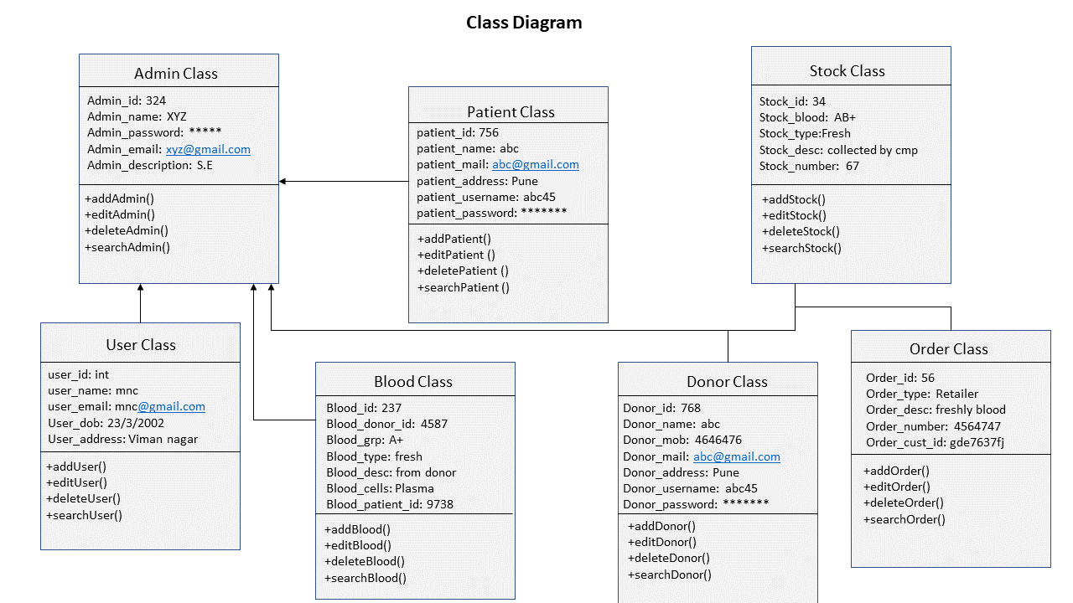

1. Sequence Diagram

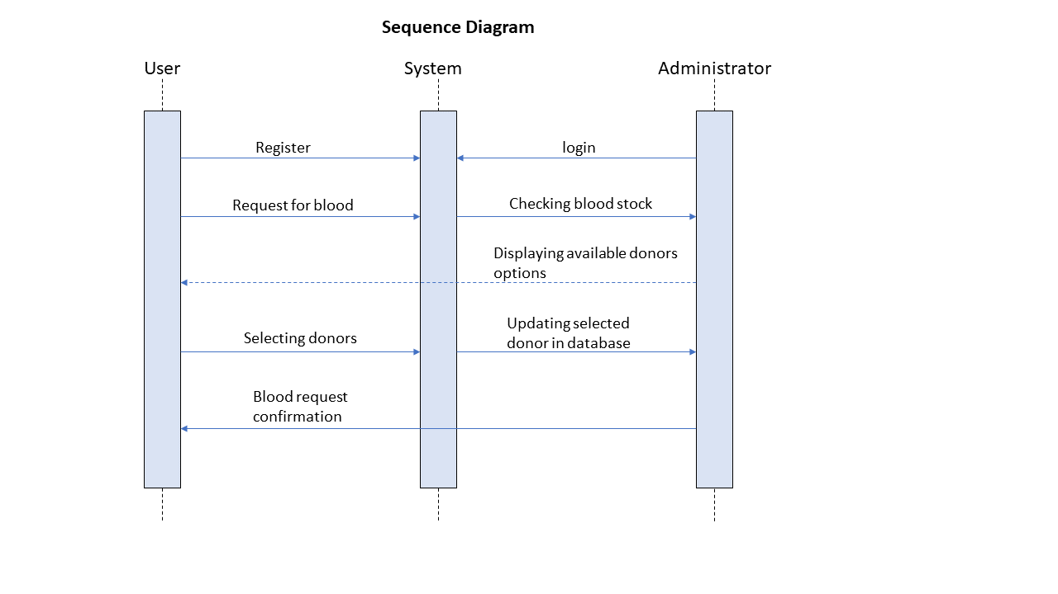

1. Activity diagram

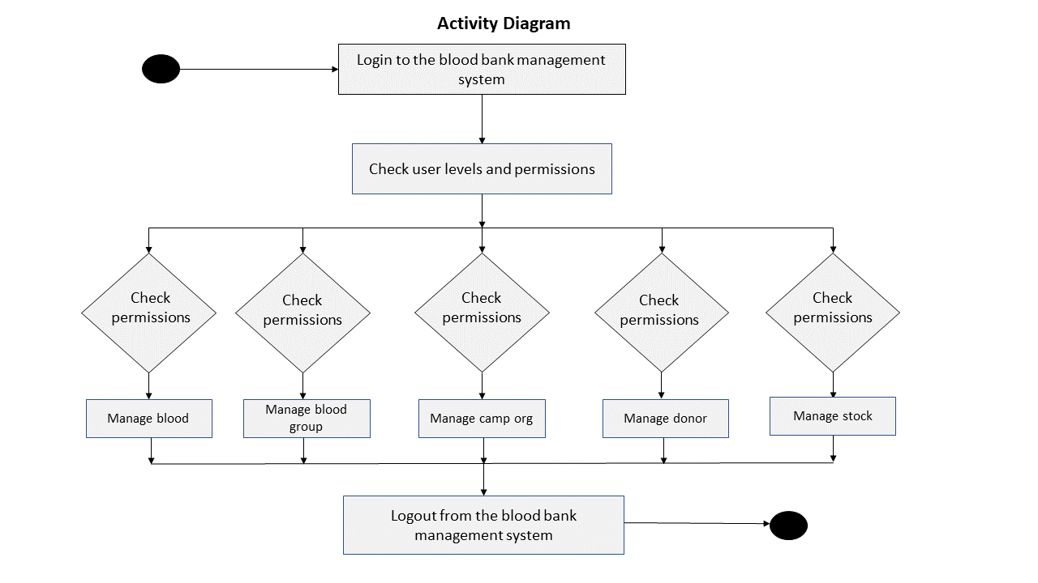

1. Deployment Diagram

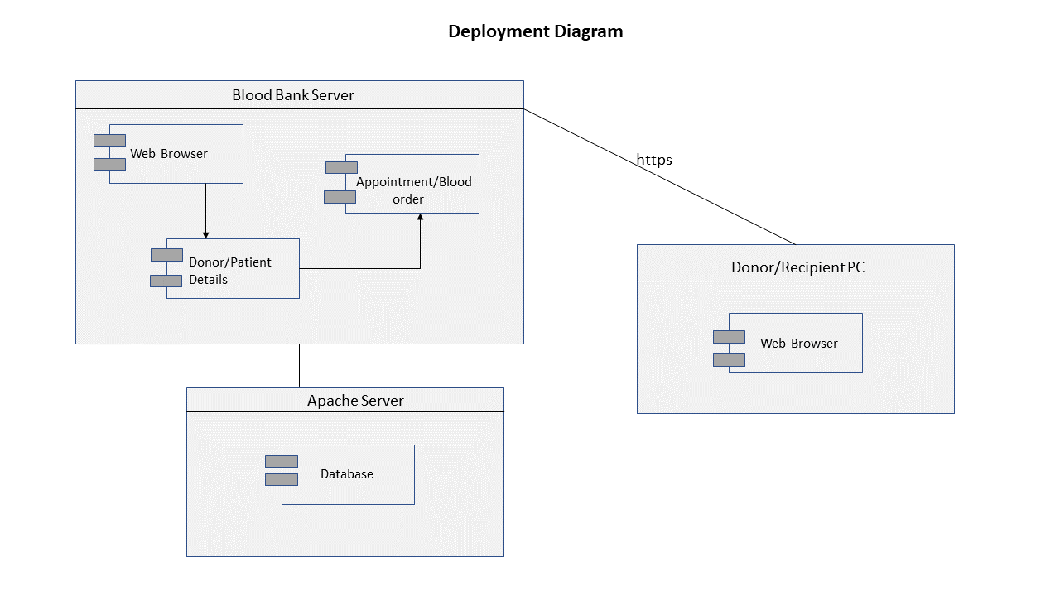

1. Object Diagram

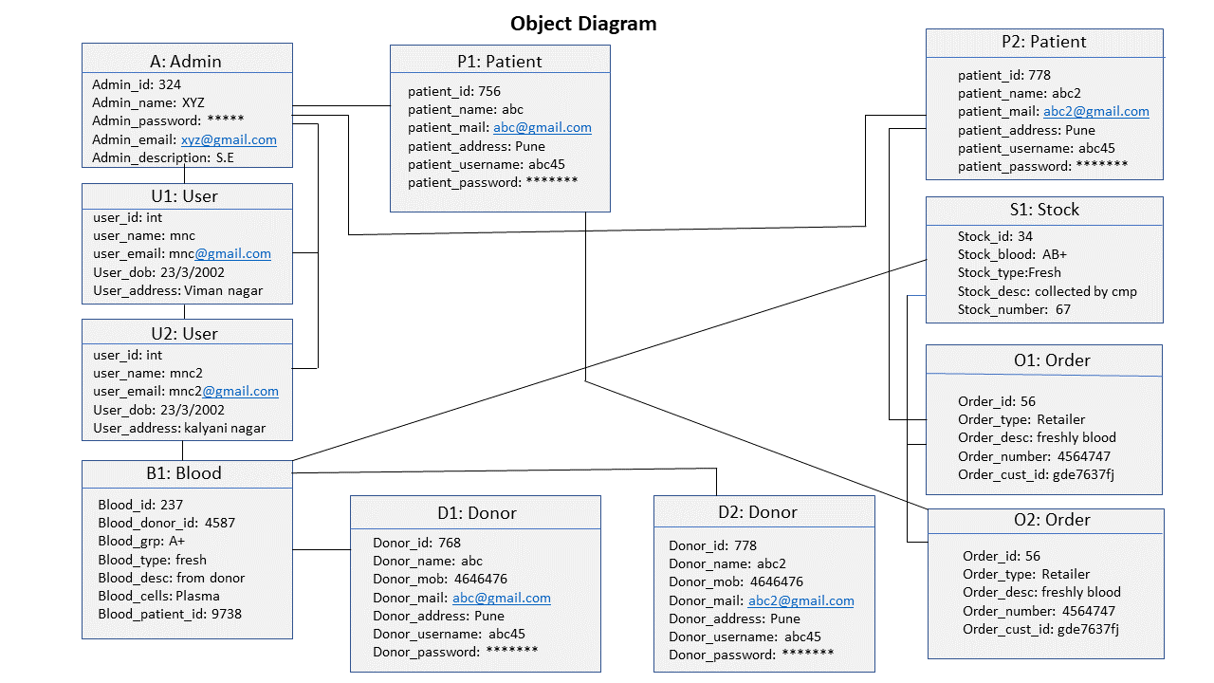

1. Component Diagram

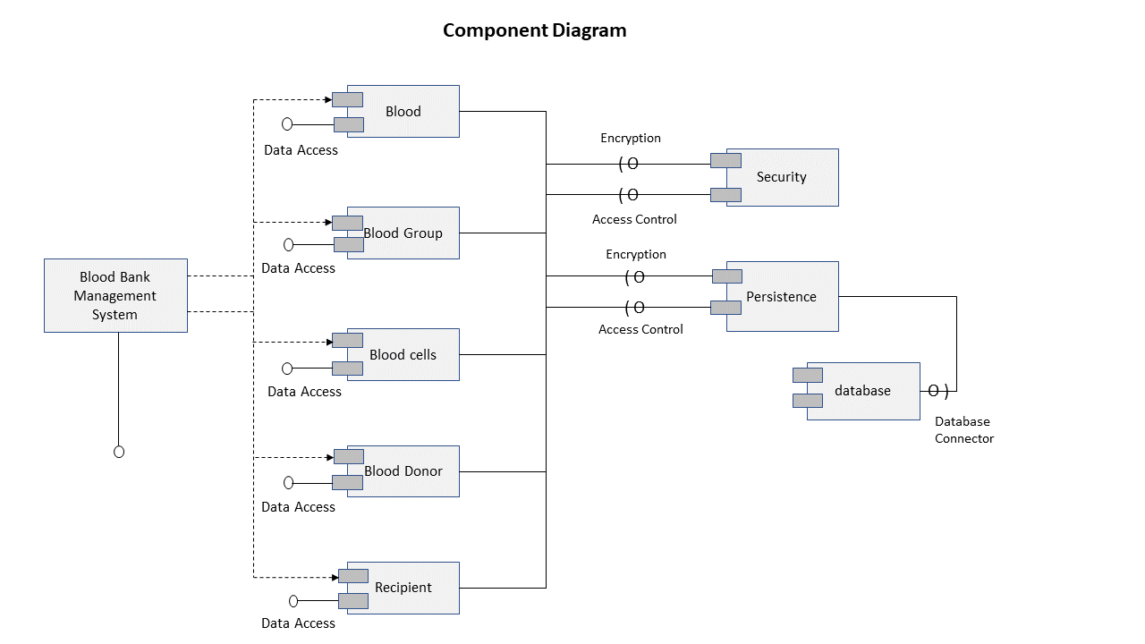

1. Use case diagram

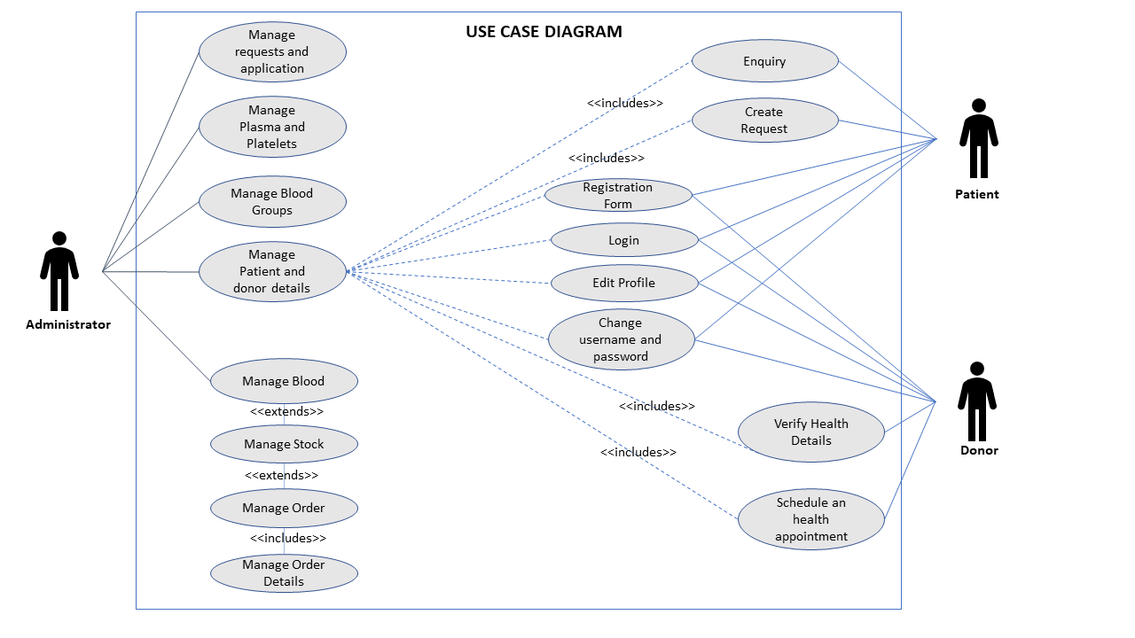

1. Artifact diagram

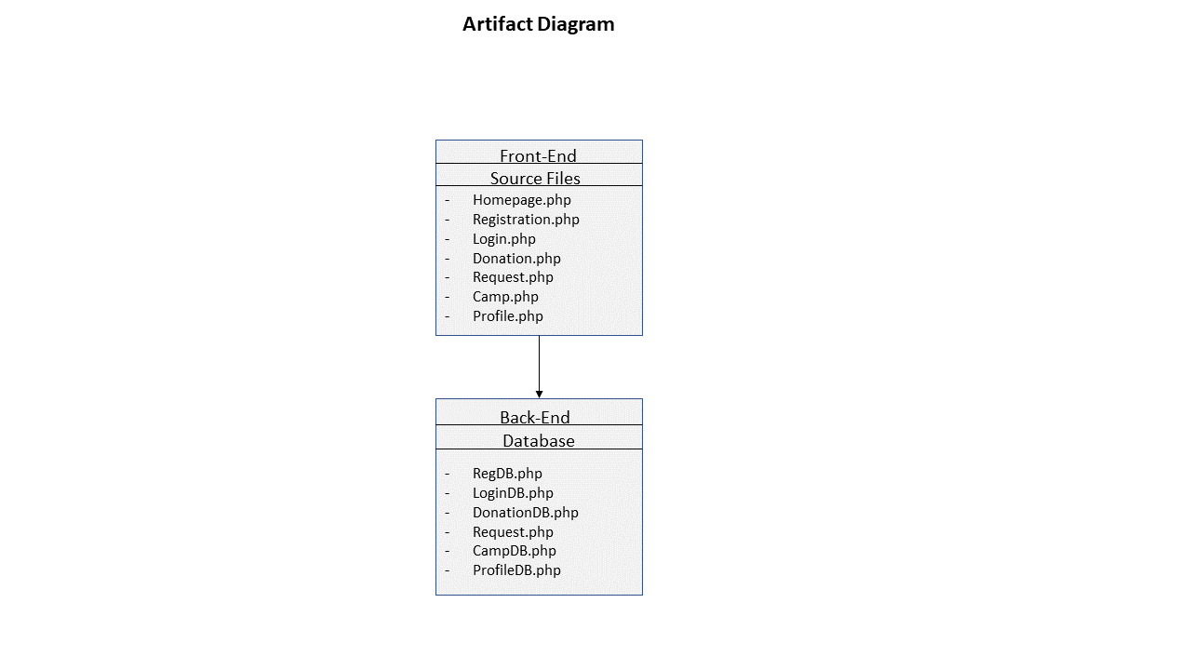

1. State chart diagram

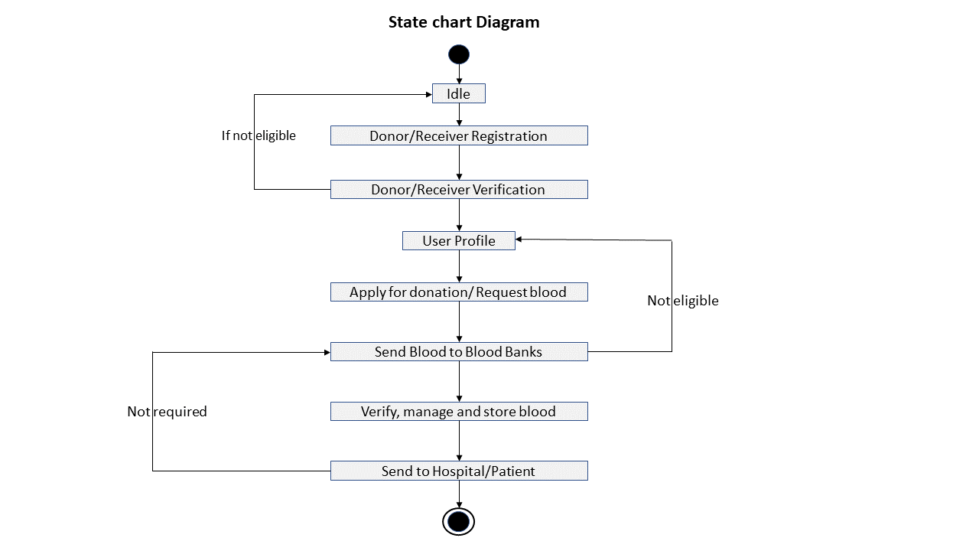

**3.3 USER INTERFACES**

The user interface of the system is very friendly, easy to understand, without the need of a user manual. The details of the user interfaces of our system are as follows:

1. User Interface
2. Admin Interface
   * 1. **User Interface**

The webpages a user has to go through and the fields the user has to fill are as:

1. **Registration Page:**
2. Name
3. Gender
4. Age
5. Email-id
6. Password
7. Mobile
8. City
9. Blood group

1. **Login Page:**
2. Email id
3. Password
4. **Home Page:** It is the home page containing a navigation bar to various pages.
5. Donate
6. Request for blood
7. Camp registration
8. Contact Us
9. About
10. Profile
11. Log Out
12. **Donate:** It contains the form to book blood donation appointment.
13. Form
14. Profile
15. Book Appointment
16. **Request for blood:** It contains the form to create the blood requests.
    1. Form
    2. Profile
    3. Book Appointment
17. **Camp Registration:** Contains section to register blood donation camps.
18. Organization details
19. Name of organization
20. Contact information

1. **Profile:** It is a page where users can update their information and keep track of their activities.
2. Personal Details
3. Appointment Booking History
4. Blood Requests
   * 1. **Admin interface**
5. **Admin login:** Contains Login for administration.
   1. Username
   2. Password
6. **Users:** Shows users that are active or inactive donors and receivers.
7. Active/ Inactive Donors
8. Active/ Inactive Receivers.
9. **Appointment Booking History:** Shows Donation appointment bookings of users
10. **Requests for blood:** Shows users that have requested for blood, plasma & platelets.
11. **Registered Blood Donation Camps:** Consists for camps that have been registered.

Chapter 4

**IMPLEMENTATION DETAILS**

* 1. **SOFTWARE REQUIREMENTS**

1. **Operating System: Windows/ Linux:**

- It works on Windows as well as Linux OS

1. **Server: XAMPP**

- XAMPP is a popular cross-platform web server that allows programmers to write and test their code on a local webserver.

1. **Programming language: PHP**

- PHP is a general-purpose server-side scripting language that we can use to develop dynamic web sites and applications. PHP only needs to be installed on the web server that will host the web application and client applications can access the server resources via web browsers.

1. **Scripting language: JavaScript, HTML, CSS**

- HTML and CSS is the best designing language for web applications. With the help of JavaScript, we have made the web page more dynamic and interactive.

1. **Framework:** **Bootstrap**

- Bootstrap is a free and open-source CSS framework directed at responsive, mobile-first front-end web development. It contains HTML, CSS and JavaScript-based design templates for typography, forms, buttons, navigation, and other interface components.

1. **Database: PostgreSQL:**

- It provides quick storage and retrieval methods.

1. **Browser: Google Chrome, Mozilla Firefox:**

- A browser helps to run the localhost server on our device and in turn, helps to execute the entire system.

**4.2 HARDWARE REQUIREMENTS**

1. CPU Processor: Pentium IV or higher
2. RAM: Minimum of 4 GB
3. ROM: Up to 10-30 GB of storage space.

Chapter 5

Outputs and report testing.

## 5.1 TEST PLAN

A test plan in software testing is a document which outlines the what, when, how, who, and more of a testing project. It contains the details of what the scope of testing is, what the test items are, who will do which testing task, what the items test/pass criteria will be, and what is needed to set up the test environment and much more.

The details of the test plan of the software testing are as follows:

* + 1. **Mode:** Manual Testing
    2. **Resource Requirements:** Developed System, Tabular structure for updating the test cases
    3. **Testing Tasks:** Graphical User Interface, Module Functionalities, Database Connectivity
    4. **Type:** White Box Testing and Black Box Testing
    5. **Test Plan Identifier: bloodbank,** TS_01, TS_02, TC-001, TC-002, TC-003, etc.
    6. **References:** Images folder was taken as a reference folder. It is a part of the system, but externally stored into a folder. “font-awesome.min.css” folder for storing icons of the project.
    7. **Test Items:** It is a "test object" or a component/subsystem to be tested. The various test items in our plan would be listed as Username field, Password field, dropdown lists, buttons, etc.
    8. **Features to be tested:**
       1. User Registration
       2. User Login
    9. **Test Deliverables:** Test Cases, Test Report, Bug Report.

#### Responsibilities and Schedule:

The below table contains the details of the schedule and responsibilities of software testing.

|  |  |  |  |  |  |
| --- | --- | --- | --- | --- | --- |
| Test Scenario | Tester Name | Testing Start Date | Test Time (HH:MM:SS) | Testing End Date | Comments |
| TS_01 | Shirley Dhawadkar | 26th April 2022 | 03:00:00 | 26th April 2022 | Test executed successfully  . |
| TS_02 | Sayali Barhate | 27th April 2022 | 02:00:00 | 27th April 2022 | Test executed successfully  . |

**5.2 BLACK BOX TESTING**

Black box testing is a type of software testing in which the functionality of the software is not known.

The testing is done without the internal knowledge of the products. Black Box Testing mainly focuses on input and output of software applications and it is entirely based on software requirements and specifications. It is also known as Behavioural Testing.

Here, mainly the testing of the registration page will be carried out by black box testing.

The test cases of the Validation of Registration page are as follows:

**Module: Registration**

**Test Scenario: Verify the Registration Functionality-**

|  |  |  |  |  |  |  |
| --- | --- | --- | --- | --- | --- | --- |
| **Test Case ID** | **Test Case**  **Name** | **Description** | **Execution Stages** | **Expected Result** | **Actual Result** | **Status** |
| TC - 001 | User Interface | Check all the text, radio buttons etc. | 1.Click on radio buttons and dropdowns | UI should be  Perfect. | UI is Perfect. | Pass |
| TC- 002 | Required_Fields1 | Check the required fields by not filling any data | 1. Do not enter any value in the field. 2. Click on the Register button | It should show an alert indicating that mandatory fields are missing. | It shows an alert indicating that mandatory fields are missing. | Pass |
| TC- 003 | Required_ Fields2 | Check user should Register by filling all the required fields | 1. Enter valid values in the required fields.  2. Click the Register button. | 1. Users should be registered successfully. 2. A successful registration message should show. 3. Mail should be sent touser | 1. Users should be registered successfully. 2. A successful registration message should show. | Pass |
| TC- 004 | Username | Check the Username contains only alphabets and whitespaces. | 1. Enter a numeric character.  2. Click on Register button | It should show any validation message | It shows a validation message | Pass |
| TC - 003 | Email _ validation1 | Check the Email text field that has an Email address without @ symbol. • Check the Email text field that has random string instead of a real email ID. | 1. Enter Invalid Email  2. Click the on-  Register Button. | It should show incorrect email. | It shows incorrect email. | Pass |
| TC- 004 | Email _ validation2 | Check All the Valid Emails. | 1. Enter valid Emails  2. Click on the Register Button. | It should show some validation message | It shows some validation message | Pass |
| TC- 005 | Password_   validation1 | Check the password limit when enter value less than min | 1. Enter value which is alphanumeric but less than 8. 2.Click on Register button | It shows Error  message. | It shows Error  message. | Pass |
| TC- 006 | Password_   validation2 | Check the password limit when enter value  greater than max | 1. Enter value which is more than 12. 2. Click on Register button | It shows Error  message. | It shows Error  message. | Pass |
| TC- 007 | Password_   validation3 | Check the password is Between 8 to 12 | 1. Enter value between 8 and 12. 2. Click on Register button | It should show some validation message | It should show some validation message | Pass |

**5.3 WHITE BOX TESTING**

White Box Testing is software testing technique in which internal structure, design and coding of software are tested to verify flow of input-output and to improve design, usability and security. In white box testing, code is visible to testers so it is also called Clear box testing, Open box testing, Transparent box testing, Code-based testing and Glass box testing.

Here, mainly the testing of the login page will be carried out by white box testing.

The test cases of the Validation of Login page are as follows:

**Module: Login**

**Test Scenario: Verify the Login Functionality**

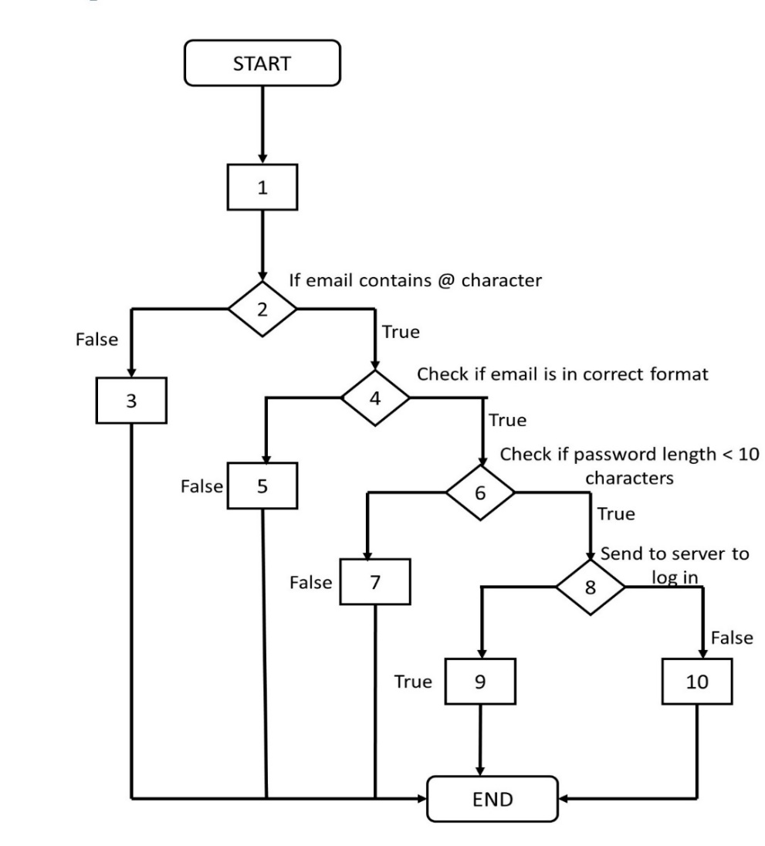

RESULTS: The testing carried out were successful and there were no bugs found during this process.

# 

## 5.4 FORM DESIGNS

## The below are the actual design view of the systems.

* **Registration Page**

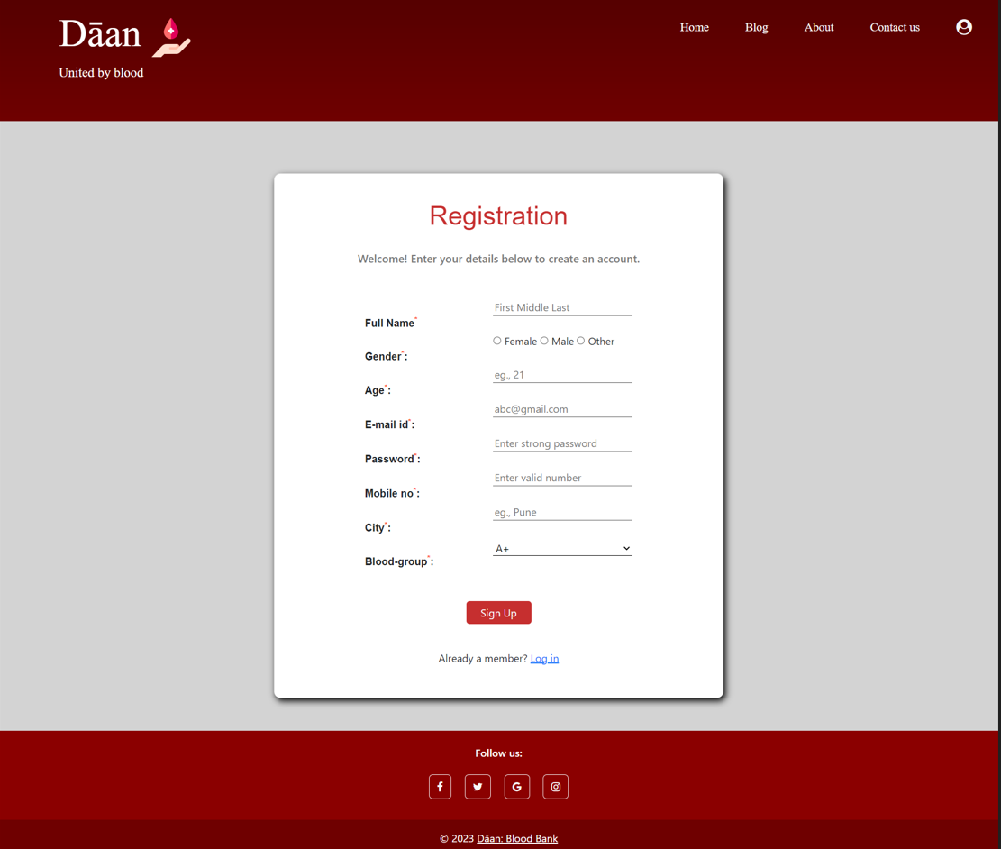

* **Login**

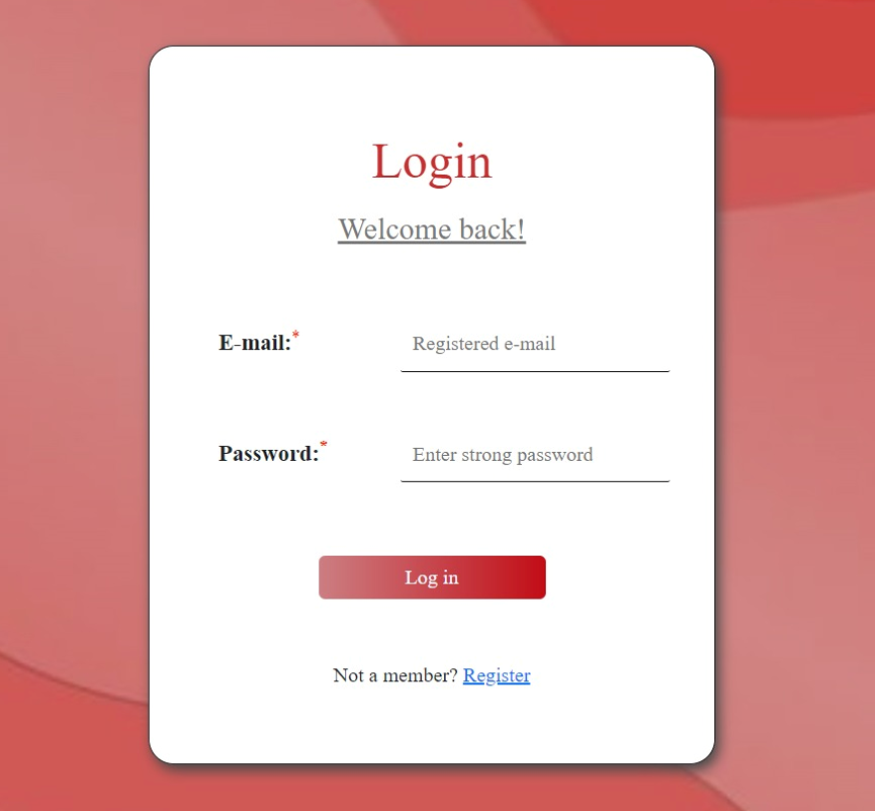

* **Camp Organization**

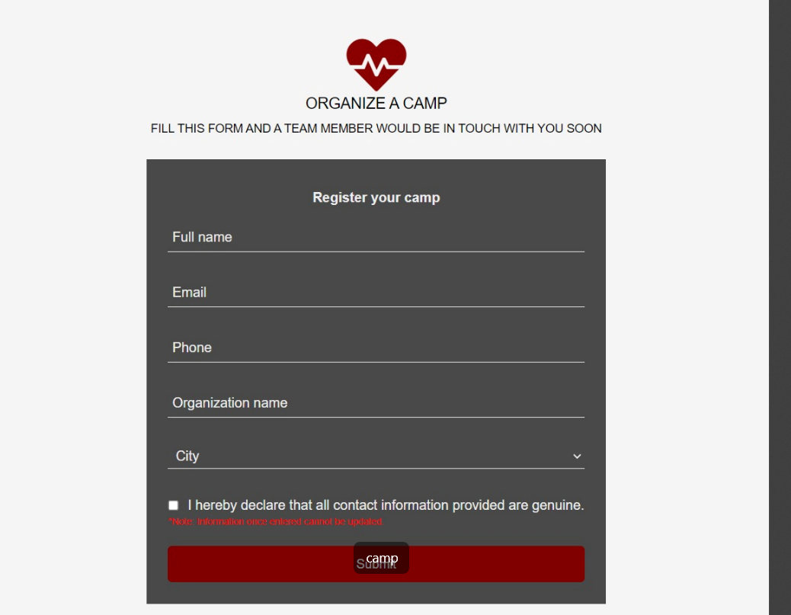

* **Contact us**

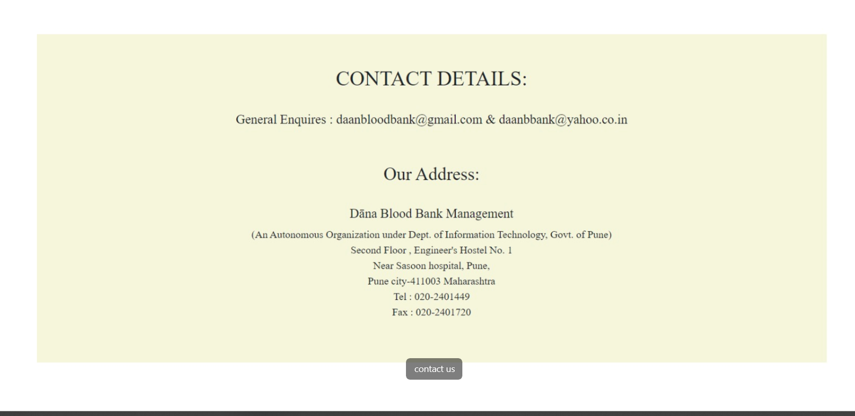

* **About us**

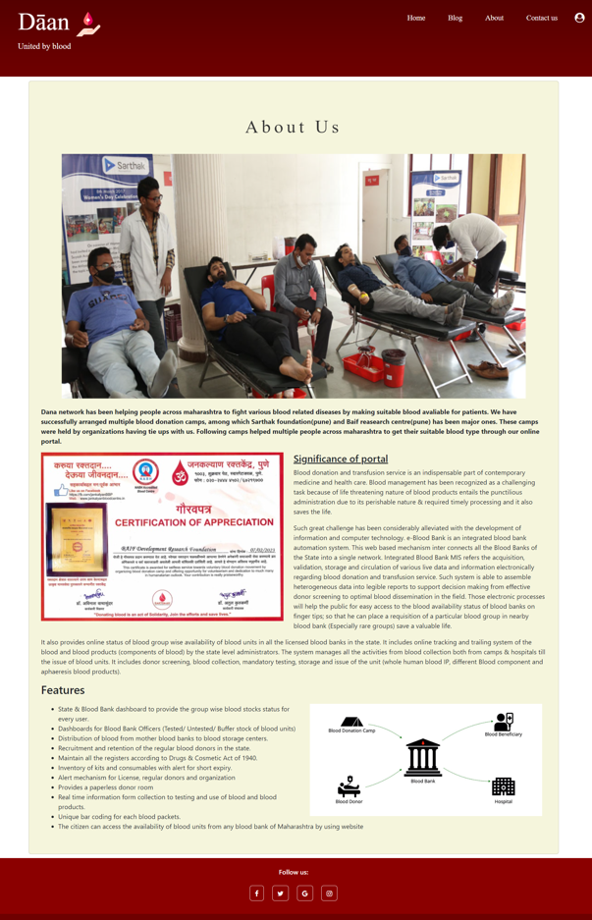

* **Blog**

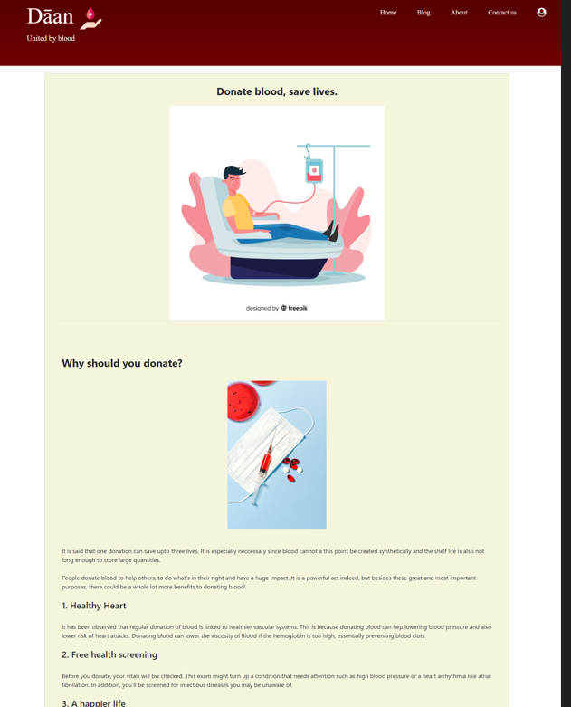

* **Home page**

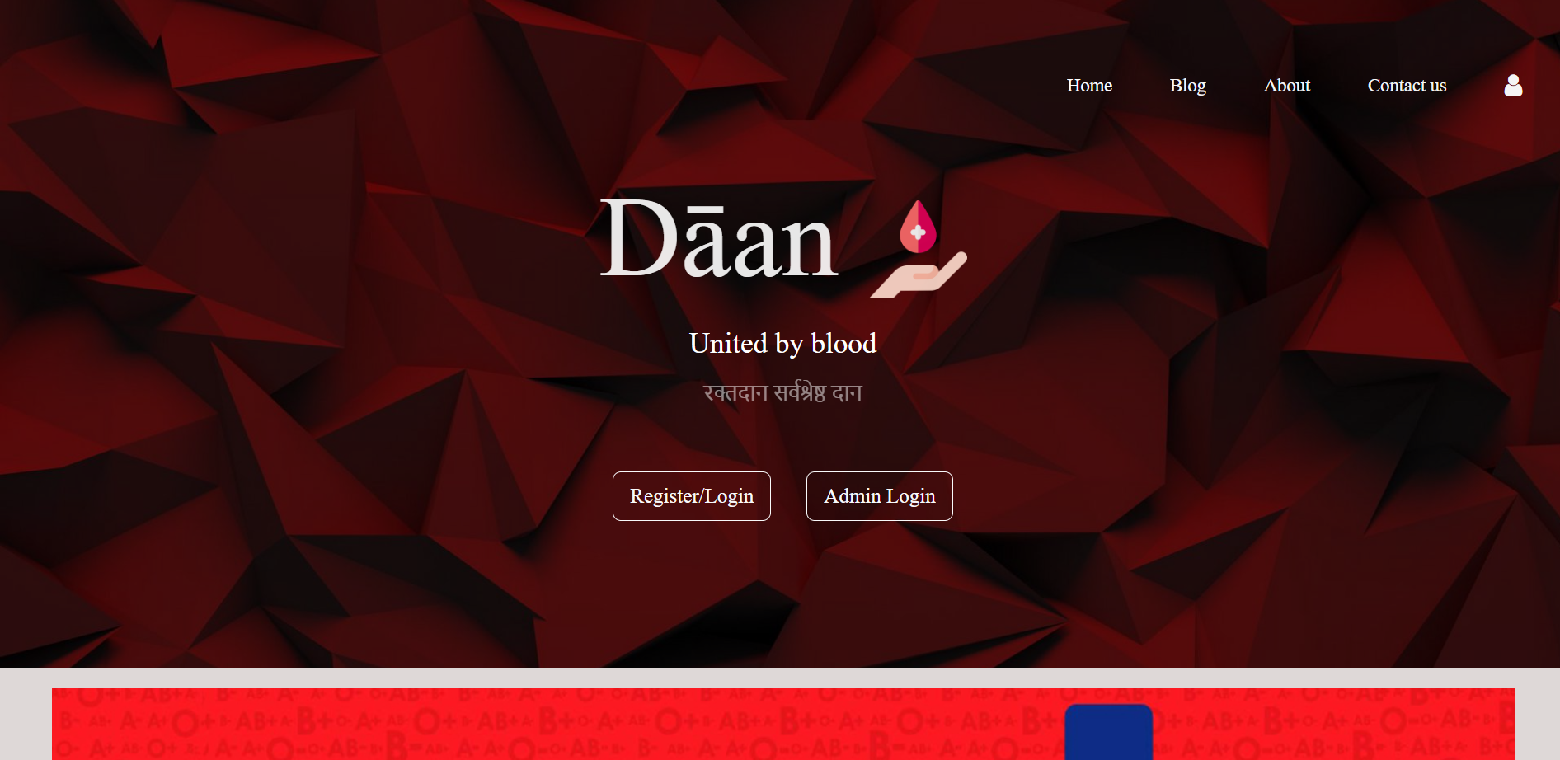

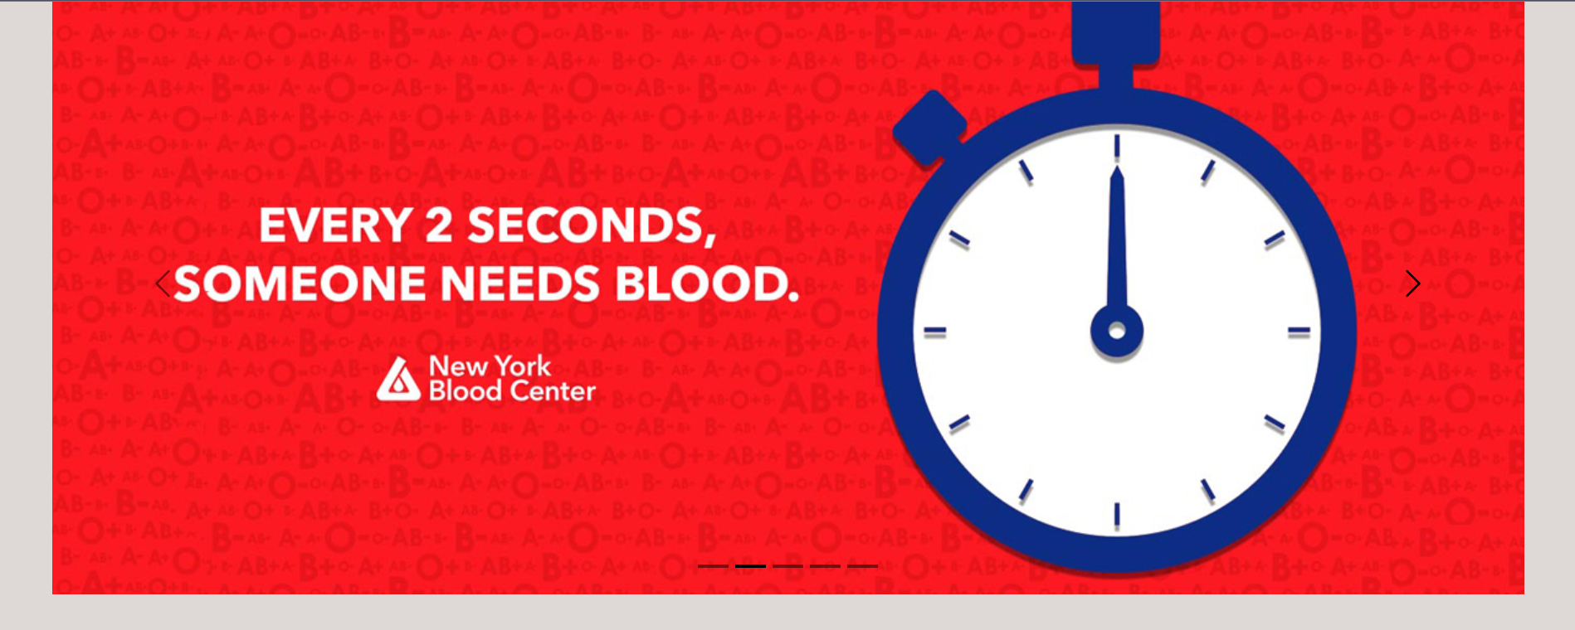

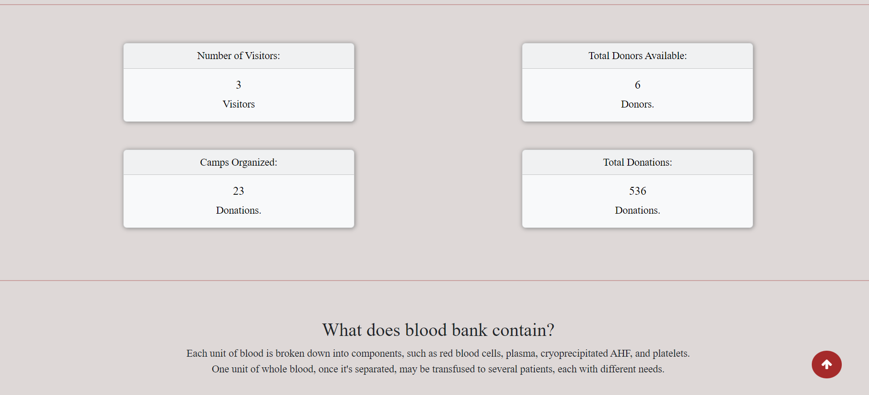

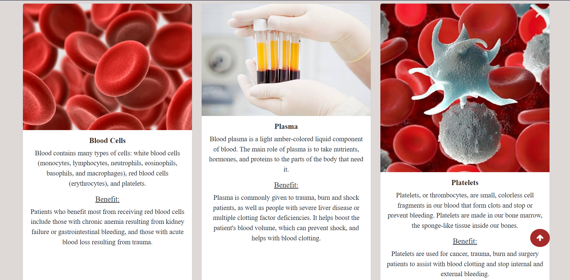

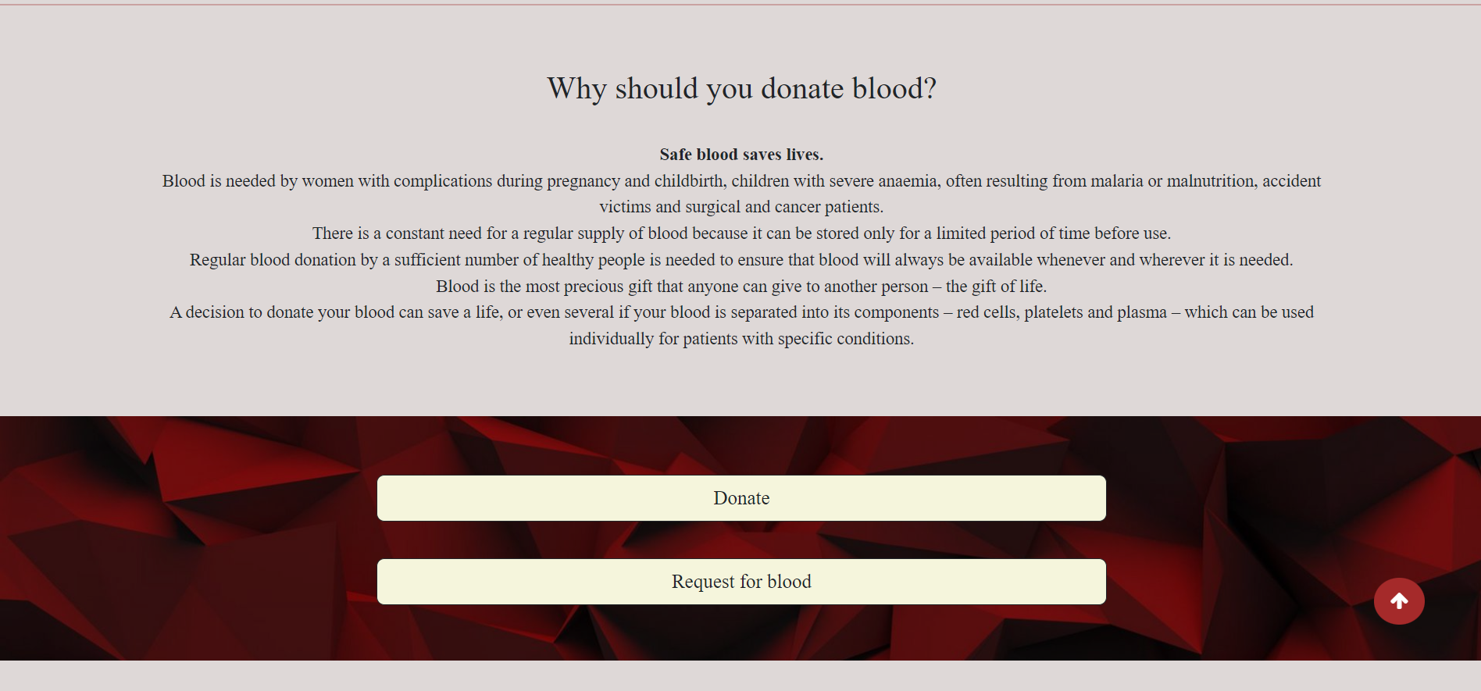

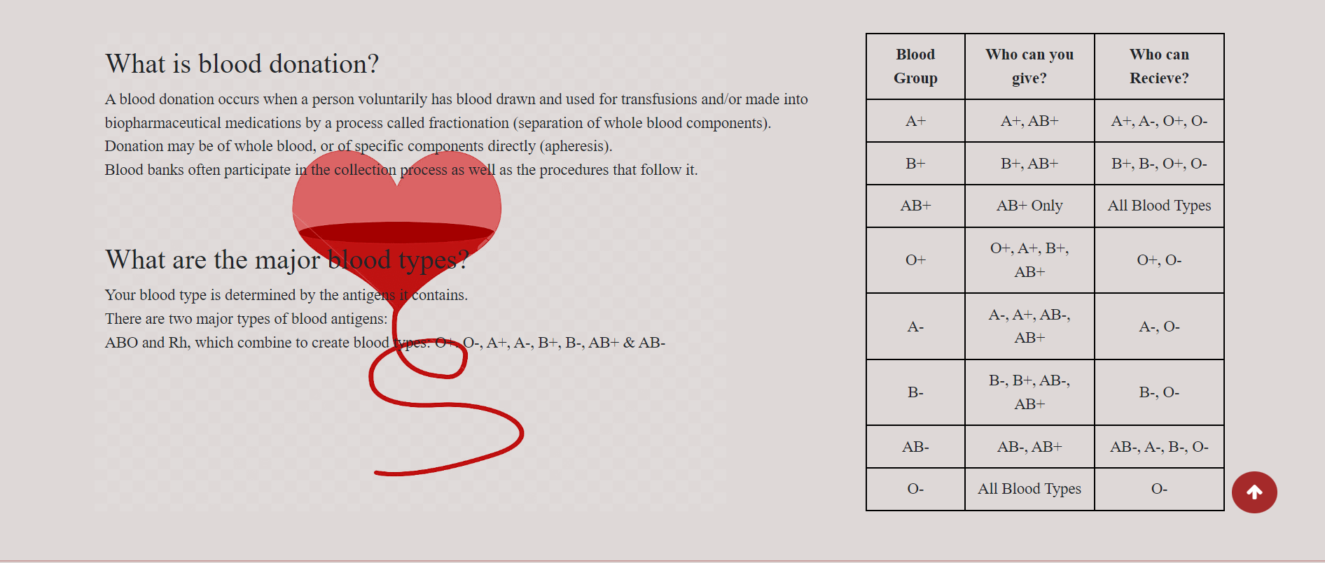

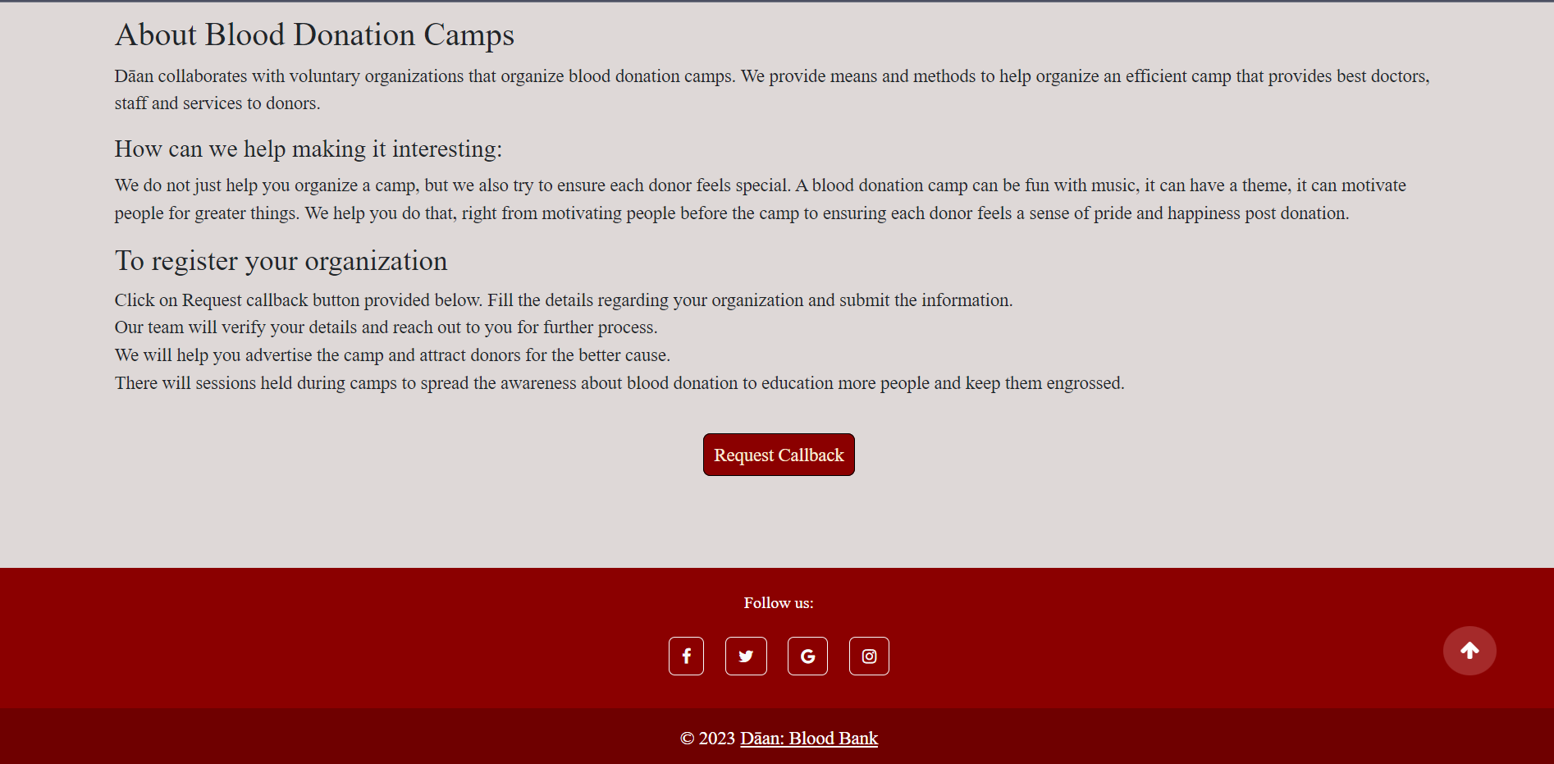

* **Admin Page**

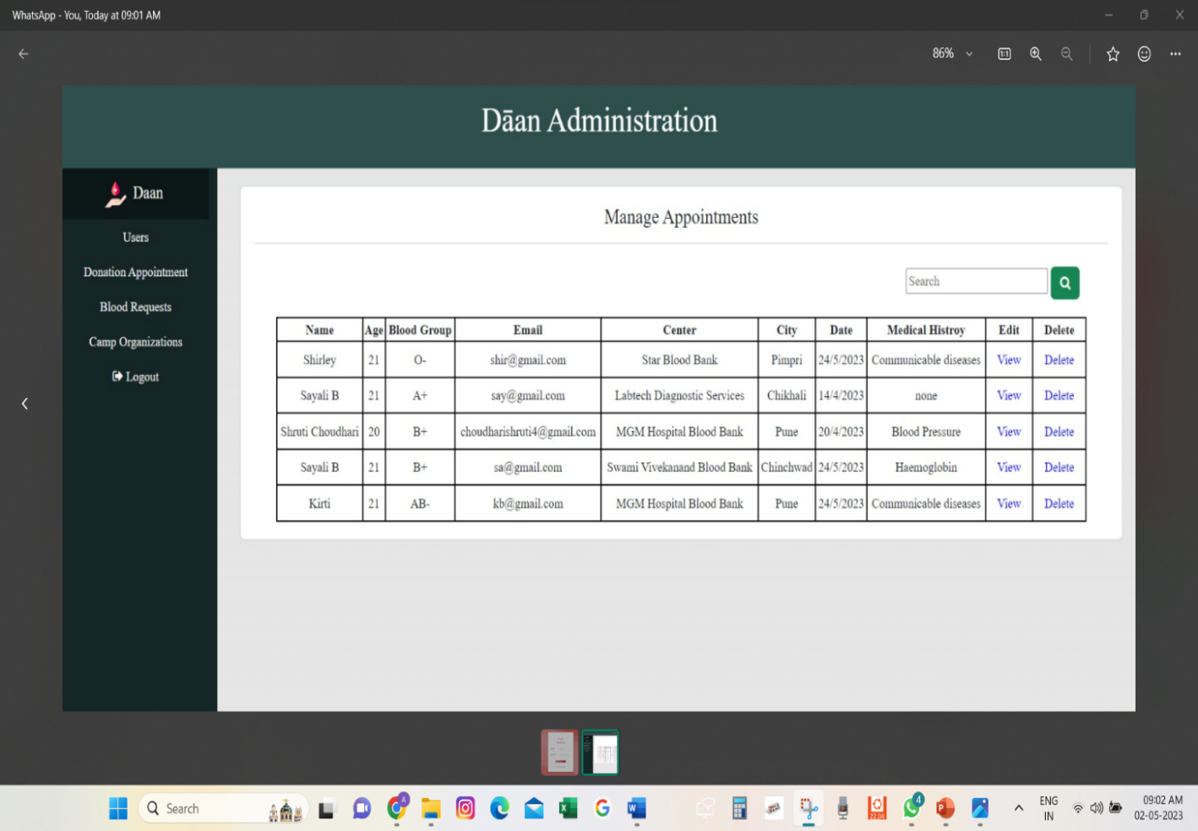

* **Profile and appointments**

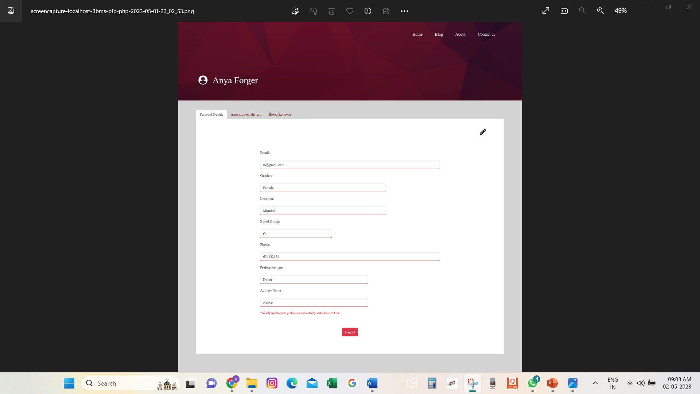

Chapter 6

**Conclusion**

* This web application was successfully created and stored all the Blood appointments, request managing and other details into the database using this application.
* The application was tested very well and the errors were properly debugged. Testing also concluded that the performance of the system is satisfactory. All the necessary output is generated.
* This system thus provides an easy way to automate all the functionalities of consumption. If this application is implemented in few consumptions, it will be helpful.

Chapter 7

**Future scope**

* Further enhancements can be made to the project, so that the website functions in a very attractive and useful manner than the present one.
* It is concluded that the application works well and satisfy the needs. It also acts as the sharing of files to the valuable resources.
* It is worth mentioning that this project work is open for further enhancement, with the expectation that it becomes more robust and better enhanced; covering every single Maharashtra site.
* For a modified system, the user needs to just login into the application and can find the available donors, nearest donation centre, suitable blood, hospitals or individuals can request for blood from the portal and get it delivered at the destination and book appointment for blood donation.

Chapter 8

**REFERENCES AND BIBLIOGRAPHY**

* + - Html, Css, Javascript | https://www.w3schools.com/
    - Bootstrap – <https://getbootstrap.com/>
    - Web Technologies- Vision Publications
    - PHP and MySQL for Dynamic Websites-Fifth Edition- Larry Ullman